**Caritas Archdiocese of Suva Disaster Preparedness 2021**



**Emergency Contacts**

|  |  |
| --- | --- |
| Fire | 910 |
| Police | 917 |
| Ambulance | 911 |
| NDMO | 3319250 |
| Mineral Resources Department | 3381611 |
| Fiji Meteorological Office | 6724888 |

**Parish Level**

1. **Preparation of evacuation centres**

* **Check pipes for water supply**
* **Toilets are working well**
* **Cyclone shutters well maintained and ready for use**
* **Stand by extra bed sheets for demarcation of areas in the Evacuation Centre**
* **Provide provisions for persons with disability eg construction of ramps for wheel chairs**
* **Provision of containers for water storage/ water tanks**

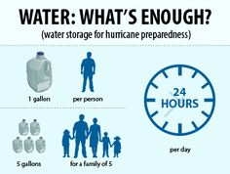

* **Provision for a First Aid Kit**
* **Trim trees in parish compounds that could damage the premises during a cyclone.**

1. **Servicing of identified vehicles for emergency transportation during disasters**
2. **Identify psychological First Aiders in the parishes**.

**Community Level/ Individual Homes**

1. **Provision of a transistor radio for update of weather bulletins**
2. **Provision of a First Aid kit**

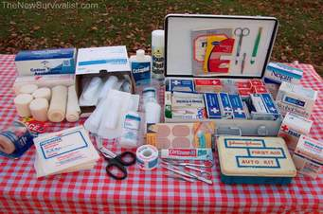

1. **Torch and new set of batteries**
2. **Containers – store clean drinking water. (fill and refill at the end of every month.**
3. **Pick up READY BAG for every individual in the house – (one pair of clothes with undergarments a few extra supplies like tooth brush, tooth paste etc. – do not make the bag too heavy.**

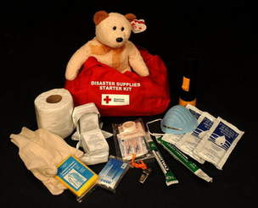

1. **Contact list of all emergency telephone lines**
2. **Trimming of tree branches posing risks to your houses and accessibility (driveways and roads)**
3. **Clean up drainages beside the house and compounds**
4. **Confirm with your families the best way to make a move prior to the onset of a disaster and the best route to be followed to the evacuation centre**
5. **Be ready to assist everyone that needs assistance during this disaster preparedness period.**
6. **Always remember to share knowledge with your neighbors**
7. **Ropes or cables to tie down houses**
8. **Allocate rooms for other people seeking shelter**
9. **Stocking food for at least for an extra fortnight**
10. **Allocate places for sheltering pets/ animals**



1. **Know the natural or man-made hazards that could affect your community, and seek advice on how to best prepare for or mitigate these hazards.**
2. **Talk to your household about potential hazards or emergencies, how they should respond to them, and what they would need to do if they had to evacuate.**
3. **Plan how your household would stay in contact with each other if separated. Identify two meeting places. One should be near your home in case of a fire, and the other should be away from home -at a neighbor or family member, in case you cannot return home.**
4. **Choose a friend or relative who lives outside of your area for family members to call and say they are okay.**
5. **Post emergency telephone numbers by the telephone and teach children how and when to use them**
6. **Make sure everyone in the household knows how to shut off gas, water and electricity at the main switches.**
7. **Join a Parish Emergency Response Team (PERT) which is organized through Parish Disaster Management. This would give you the necessary training in the basic requirements for identifying potential hazards and, if necessary, assisting in the response to hazards which may affect your community**



**EMERGENCY KIT CHECHLIST**

**An emergency kit is a list/ collection of items that you may need in an emergency. As we approach the Cyclone season given below are some the items that can assist you get started.**

**Water- 4 liters/ 1 gallon per person per day**

**Food enough to last for 5 days**



**Flash lights with 2-3 sets of batteries**



** Radio (update of weather bulletin)**

**Extra batteries**



** First Aid Kit**

** Medications**

** Family and Emergency contact information**

** Spare set of house and car keys**

** Mobile with charges**

** Personal documents**

** Extra clothing and blankets**

 **Utensils, can openers**

**10 THINGS TO KNOW ABOUT STRENGTHENING HOMES IN DISASTER PREPAREDNESS.**



1. Trim tree branches in your compound to prevent damage from flying broken branches.
2. Ready prepare proper hurricane shutter for your windows to protect you from flying debris.
3. Bring in doors all equipment/ furniture/ items that are loose outside to prevent them from blowing around and damaging your home.
4. Reinforce and secure your doors well including the garage doors on your property
5. Move vehicles in the garage or safer location if you are also anticipating floods.
6. Procure ropes or cables to tie homes down to assist the roofing screws and nails.
7. Clean all surrounding drains so that its free from debris that can cause blockage resulting in flooding inundating homes.
8. Rearrange furniture in the lounge area to allow evacuating families or individuals during the disaster
9. Ensure toilet systems are working well and store enough water supply to cater for the extra heads if the is a water cut during and after the disaster
10. Carefully dismantle Sky Pacific discs and solar power panels to be stored inside the house until the disaster is cleared.