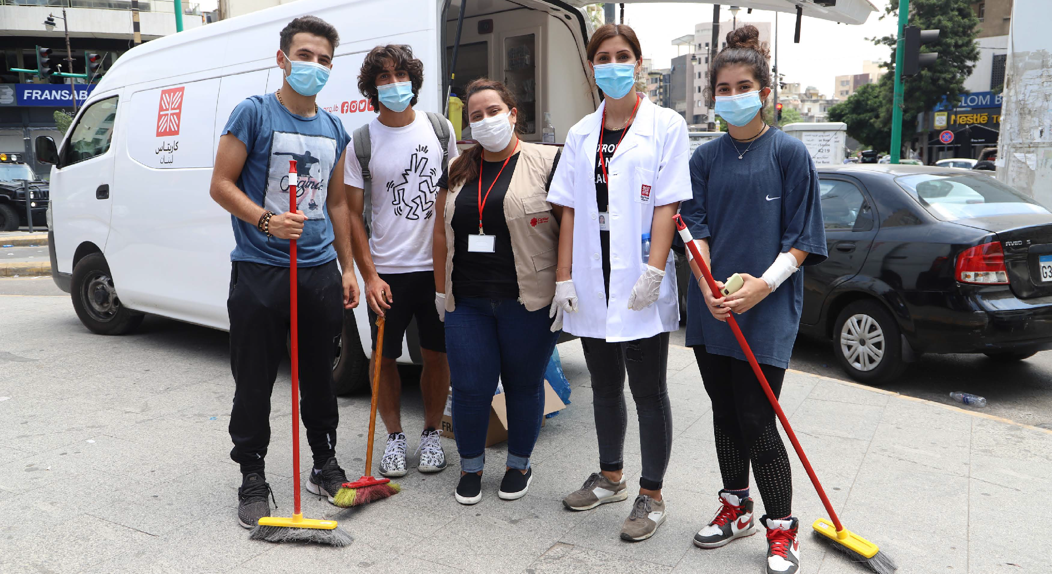


LENT
2022
WEEKLY ACTIVITIES

Called to Be Peacemakers: Building Dreams Together

Resources Overview
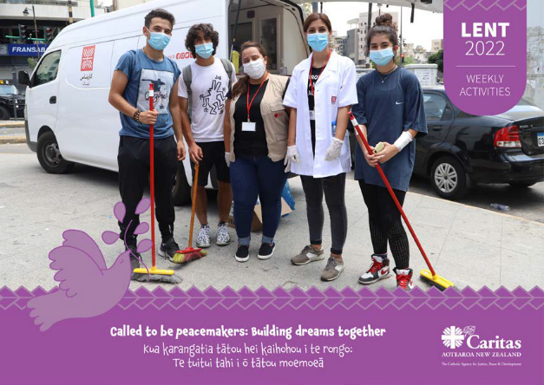
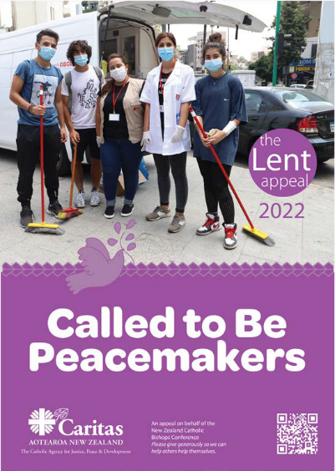
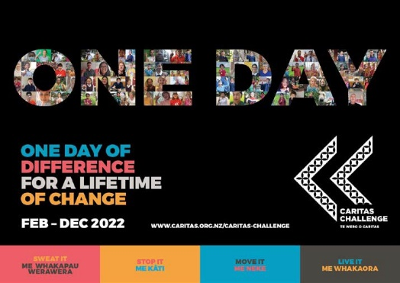
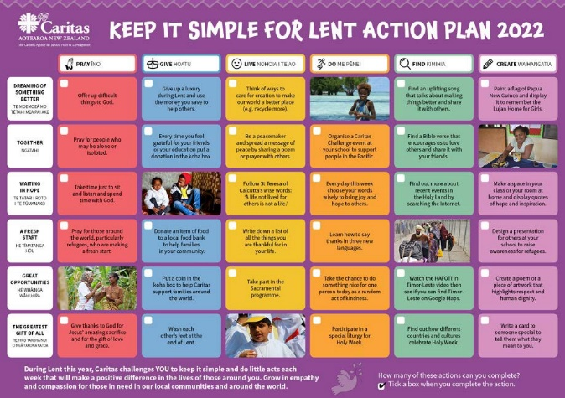
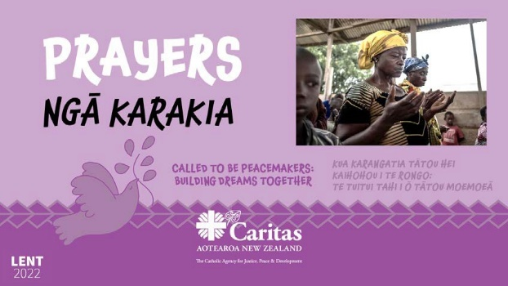
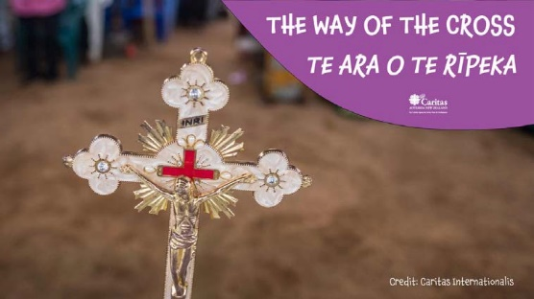
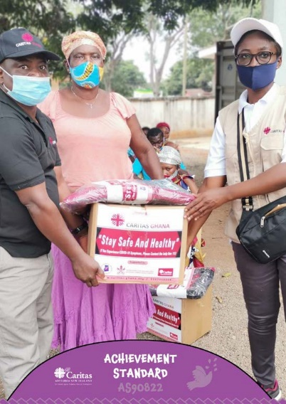


WEEKLY ACTIVITIES
LENT POSTER
ACTION PLAN
PRAYERS
ACHIEVEMENT
STANDARDS

WEEKLY ACTIVITIES

PRAYERS

LENT POSTER
ACHIEVEMENT STANDARD

THE WAY OF THE CROSS

ACTION PLAN

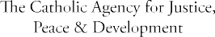

“Dear young people, do not bury your talents, the gifts that God has given you! Do not be afraid to dream of great things!”
– Pope Francis (Twitter), 2013

CARITAS CHALLENGE POSTER

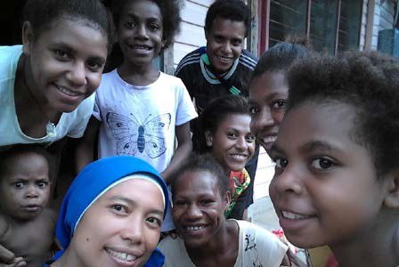
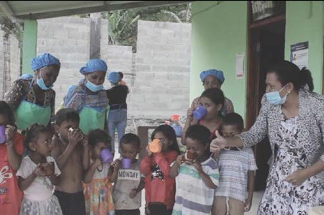


TEACHER GUIDE
Greatest Gift of All
WEEK SIX
Great Opportunities
WEEK FIVE
Dreaming of Something Better
WEEK ONE
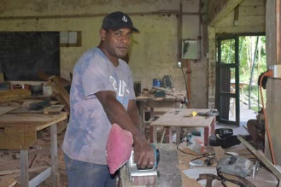
This series of resources has been designed for teachers and students to use during Lent 2022. For each of the six weeks of Lent there is a sub-theme and country focus that relates to the overall theme of being called to be peacemakers and building dreams together.
Together
WEEK TWO

Unique activities have been suggested for the different year levels in response to what has been covered in the lesson.
Each lesson includes the following elements:
Prayer q Theme Outline q Gospel Reading q Caritas Focus
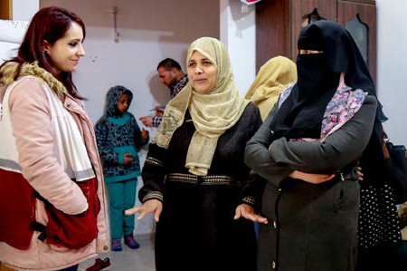
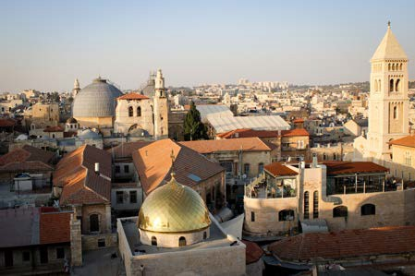
q Reflection q Questions for Students q Photo Board
q Response Activity q Possible Lent Actions
Waiting in Hope
WEEK THREE
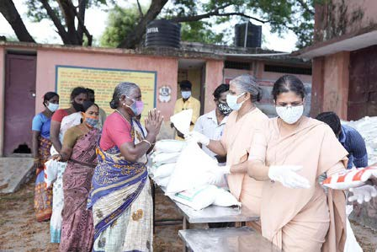
A Fresh Start
WEEK FOUR

CURRICULUM CONNECTIONS
Key Competencies | Curriculum Values
Thinking | Diversity
Managing self | Equity
Relating to others | Community and participation
Participating and contributing | Integrity
Using languages, symbols and texts | Respect
 | Innovation
Principles
Catholic Social Teaching
Cultural diversity
Inclusion
Community engagement
Future focus

WEEK ONE

As Lent begins we draw closer to God and remember Jesus’ sacrifice on the cross and his love for others. We are challenged to put others before ourselves and dream for a better world. It is through simple acts of love by individuals (starting with us) that can transform our world for the better.
Theme: Dreaming of Something Better

“How important it is to dream together… By ourselves, we risk seeing mirages, things that are not there. Dreams, on the other hand, are built together.” - Pope Francis, Fratelli Tutti, #8

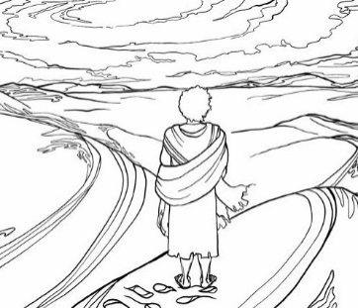

Caritas supports children to have clean water for drinking. This is health issue for everyone but especially our school children. One of the basic necessities in life.

Let us help towards collecting funds for the water project in school communities that need clean drinking water.

Caritas Focus: Clean Drinking Water For Children

Luke 4:1-13
Summary:
- Jesus is led by the Spirit into the wilderness where he is tempted by the devil for 40 days.
- During this time he did not eat anything.
- The devil tries to tempt Jesus to change a stone into bread.
- Jesus recites scripture saying, ‘One does not live on bread alone’.
- Again the devil tempts Jesus offering him all the kingdoms of the world if he will worship him.
- Jesus again quotes Scripture saying, ‘Worship the Lord your God, and serve only him.’
- The devil tempts Jesus a third time challenging him to prove he is the Son of God by throwing himself on the pinnacle of the temple.
- Jesus refuses saying, ‘Do not put the Lord your God to the test.’
- The devil departed from Jesus when he had finished all the tests.
Read the full Gospel reading by clicking here
Sunday Gospel Reading

Lord Jesus, guide us this day as we begin this season of Lent. May your Spirit lead us now as you were led in the desert for forty days.
Help us to overcome the challenges we face in our lives. Help us also to dream of something better and bring peace, light and hope into the world. We make this prayer
through Christ our Lord. Amen.
Prayer

- Is there something special that you could do during Lent this year?
- Can you think of anyone close to you who you could pray for during Lent?
Questions for Students

It is hard to imagine how hard it must have been for Jesus to stay strong for such a long time out in the wilderness. He showed great strength and faith to overcome the devil. He was aware of something better to come. Jesus, himself, would change the world for the good of all.
Many of the girls living in Lujan Home have experienced some very hard challenges and have shown great strength and resilience. The Lujan Home runs on the providence of God, meaning that they run their organization trusting that God will provide. In spite of the worry that food and funding will run out they have continued to dream of
a life that is better for the girls. Their strength and faith remind us all to trust in God’s will in every circumstance.
Reflection


PHOTO BOARD: CLEAN WATER FOR CHILDREN
CST Spotlight
Solidarity
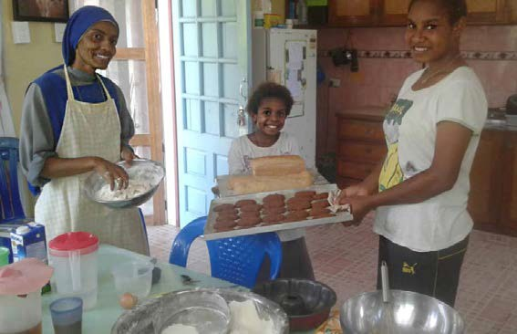
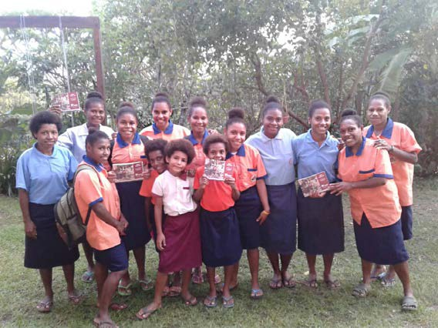
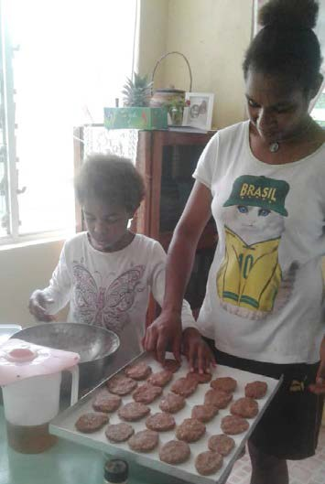
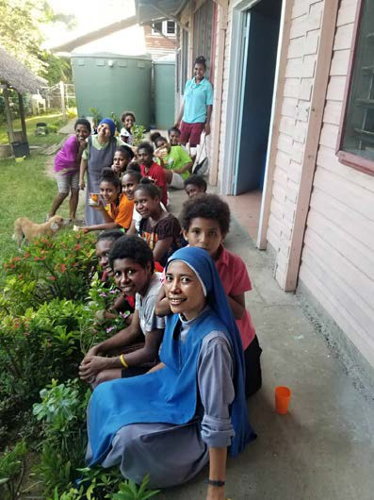
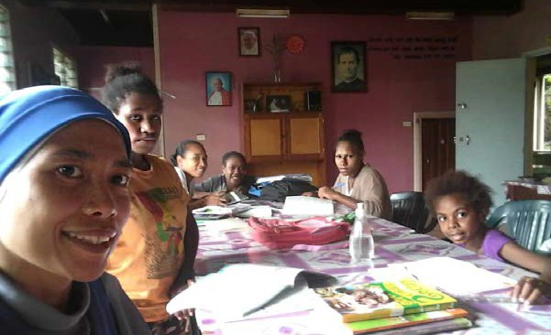
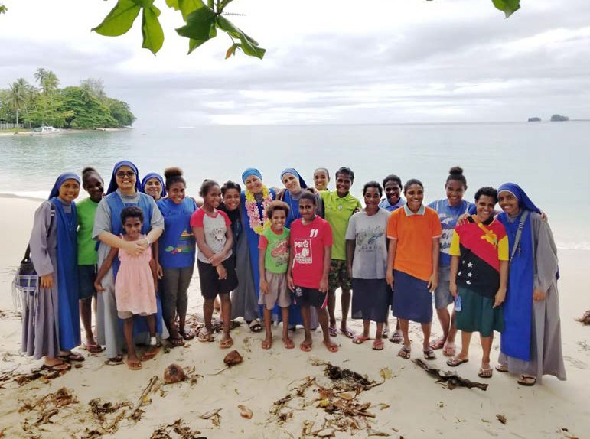
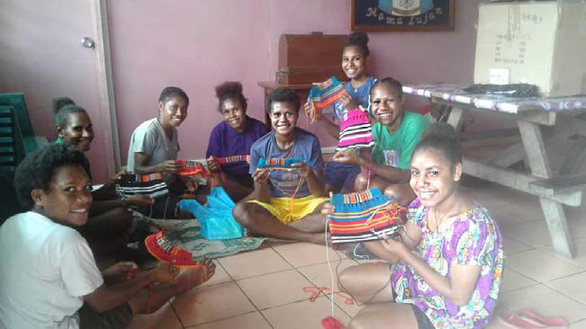
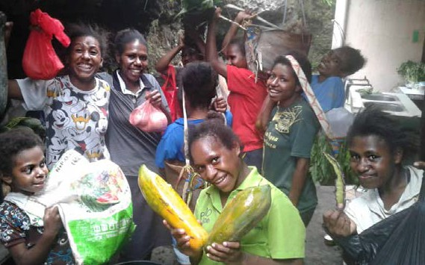
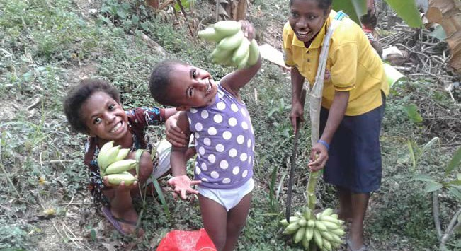
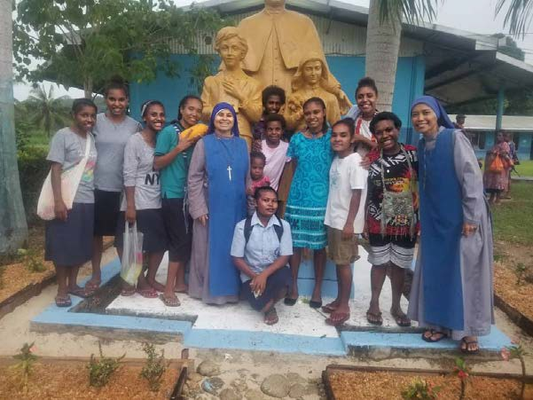
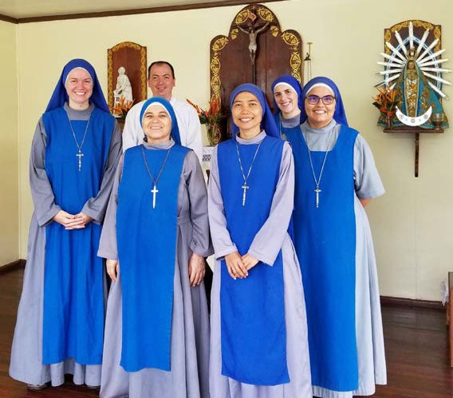
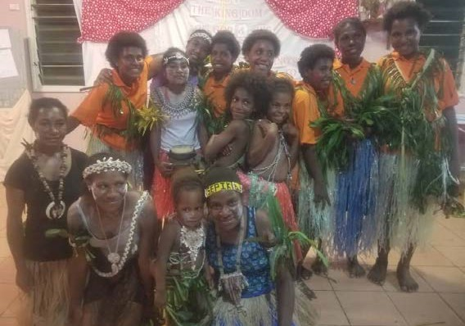

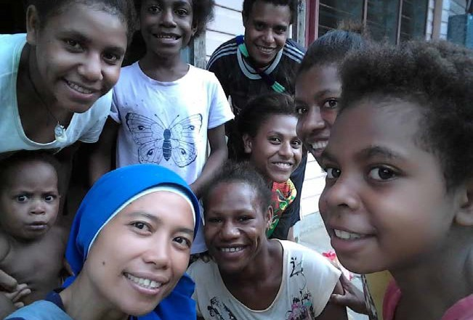
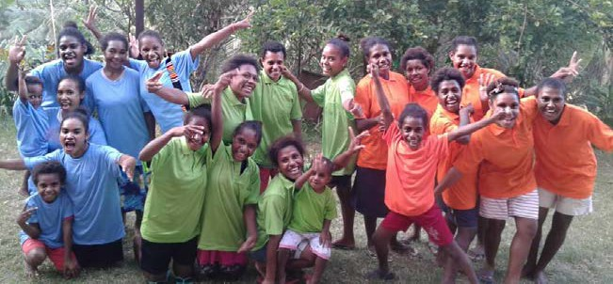
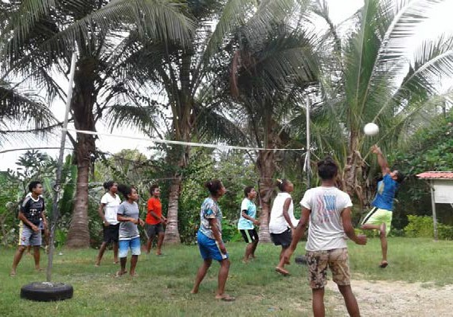
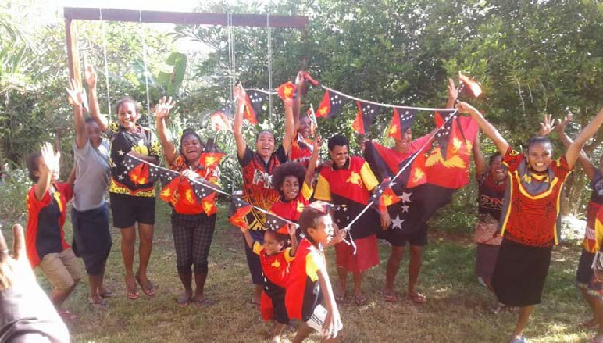
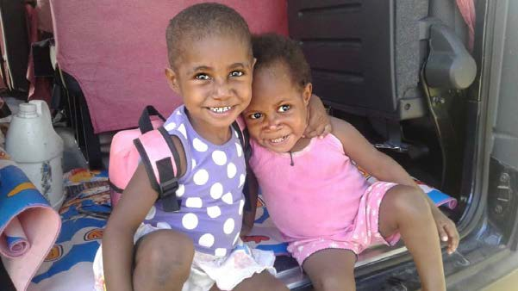
What stands out in these images?

WEEK ONE ACTIVITY IDEAS

Have a class discussion about your best dreams. Who has had the weirdest dream?
Close your eyes and try to imagine/dream of something good happening this month. Share with others what you saw.
Draw a picture of your chosen dream and display this for others to enjoy.
Y1-4 (JUNIOR PRIMARY)

Write a letter addressed to the Sisters at St Christopher’s Home and the children staying there.
You could let them know that you are inspired by what they do and that you are praying for them all.
You can e-mail your letter to executive.director@caritasfiji.com and we can pass it on so that they know we are building dreams together.
Y5-8 (SENIOR PRIMARY)

Choose a prominent place to display the photos showing the children working, playing, eating and drinking water.
Every day through Lent take time to pray for those living in need of clean drinking water.

Seek out poor children in school who may need food stuff to be collected and donated to them.
Y9-10 (JUNIOR SECONDARY)

We read that Jesus used Scripture to deny the devil and his tests.
Think of a time when you’ve given into temptation and then felt really bad about it. Look through Scripture to find a verse that would have helped you avoid the temptation.
Write this verse somewhere so you can see it often as a useful reminder.
Y11-13 (SENIOR SECONDARY)






KEEP IT SIMPLE FOR LENT
Check out the simple actions outlined in the Action Plan for this week. Take the challenge to complete some of these.
PRAY
GIVE
LIVE
FIND
CREATE
Offer up difficult things to God.
Give up a luxury during Lent and use the money you save to help others.
Think of ways to care for creation to make our world a better place
(e.g. recycle more).
Find an uplifting song that talks about making things better and share it with others.
Paint a flag of Papua New Guinea and display it to remember the Lujan Home for Girls.

WEEK TWO

God of encounter, awaken us to your living presence within us. May we hear your voice within the Scriptures as they show us your perfect will.
Help us to see others through your eyes and to work with them to bring peace, hope and light into the world. May your will be done. Amen.
Prayer

Pope Francis wrote a letter to everyone in 2020 called Fratelli Tutti, reminding us that we are part of one human family and need to care for one another.
As we continue on our Lenten journey let’s keep putting others first and think of ways we can be better by working together.
Theme: Together

“Let us dream, then, as a single human family… each of us with his or her own voice, brothers and sisters all.” – Pope Francis, Fratelli Tutti, #8



At the Tutu Rural Training Centre (TRTC) in Fiji, young men and women are being transformed. Training courses are provided at Tutu, to help learners develop the spiritual, intellectual and physical aspects of their life and make a positive impact in their community.
Teachers work together with the young men and women to fulfil their talents and potential and help them make the most of their opportunities. Young farmers learn skills in agriculture and become
confident leaders in their villages. The single women’s course helps the students to discover their natural talents and use them in small-business opportunities involving farming, textiles, handicrafts and cooking.
Caritas Focus: Tutu Rural Training Centre

- Who do you have a chance to work alongside to help in the next few weeks?
- How will you put Fratelli Tutti into action by being a global neighbour?
Questions for Students

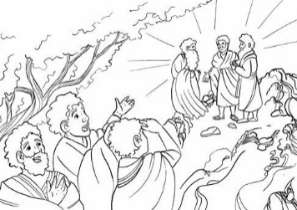

Luke 9:28-36
Summary:
- Jesus took Peter, James and John and went up a mountain to pray.
- While he was praying, Jesus became dazzling white.
- Moses and Elijah appeared and were talking to Jesus.
- They too appeared in glory and were discussing Jesus’ departure.
- Peter and the others were tired but saw all that took place.
- Peter without thinking called out to Jesus offering to make three dwellings for Jesus, Moses and Elijah.
- A cloud appeared and enveloped them terrifying the three disciples.
- A voice was heard within the cloud saying, “This is my Son, my Chosen; listen to him!”
- Jesus was then found alone.
- The disciples never told anyone what happened.
Read the full Gospel reading by clicking here
Sunday Gospel Reading

Jesus was transformed on the mountain and this surprised his disciples and they saw him for who he really was.
Students at the Rural Training Centre are also transformed and are supported by others to find out more about themselves too. It is with the help of teachers and their peers that they find opportunities for the future.
Moses and Elijah were present with Jesus to confirm what was to come and what Jesus was to carry out. Sometimes we need those around us to provide guidance and confirmation of where we are going.
Fiji has had a tough time lately with cyclones and the impacts of the pandemic. However, the people have been strong and resilient
and shown, in places like Tutu, that they can still work together for a positive future.
Reflection


PHOTO BOARD: FIJI
CST Spotlight
Participation

CHALLENGES and DESPAIR

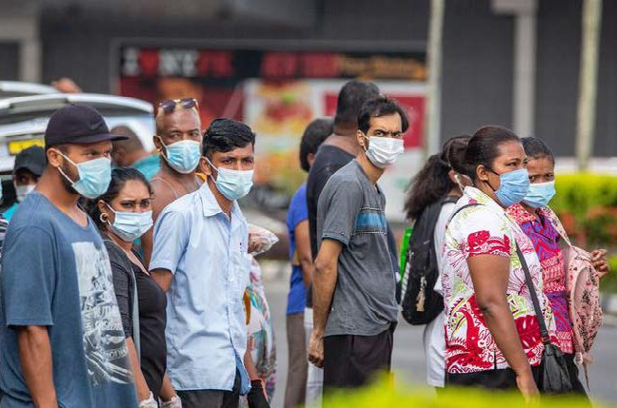
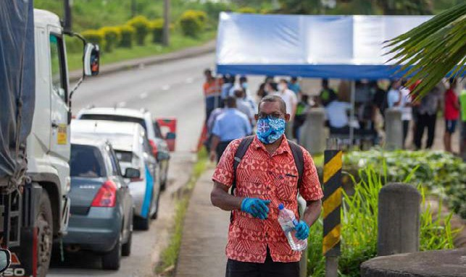
Cyclone Yasa and Ana caused problems throughout Fiji in December 2020 and January 2021.
Credit: Caritas Fiji
Credit: SEEP
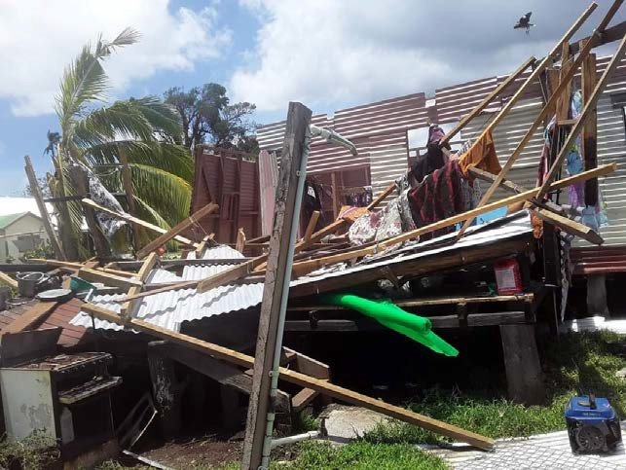
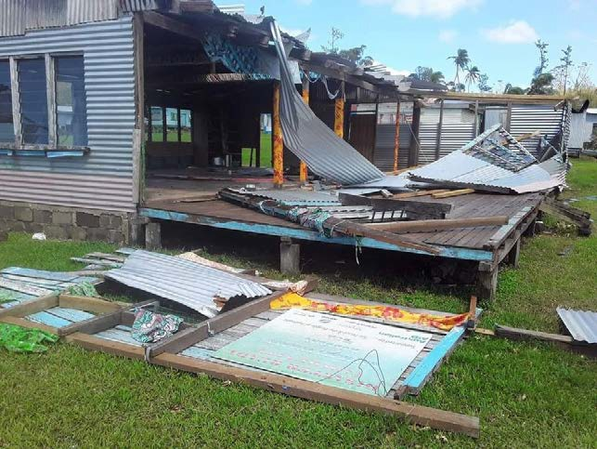

2021 was a hard year in Fiji due to the pandemic. Midway through the year, there was a sharp surge in COVID cases.
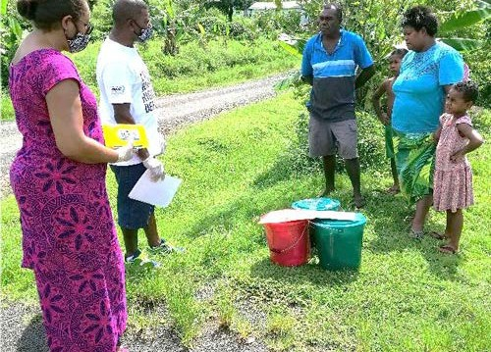
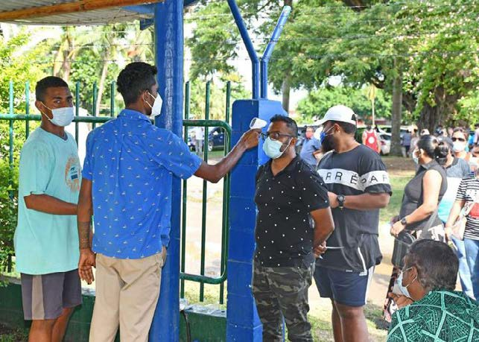

HOPE and COMMUNITY
Credit: RNZ
Credit: Tutu Rural Training Centre
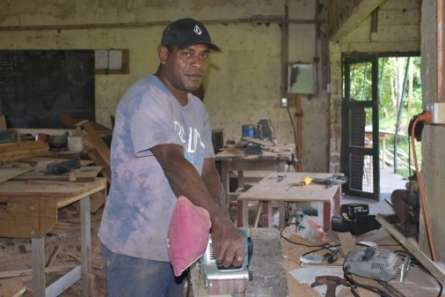
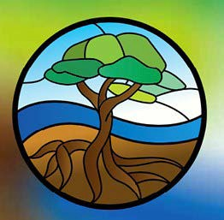
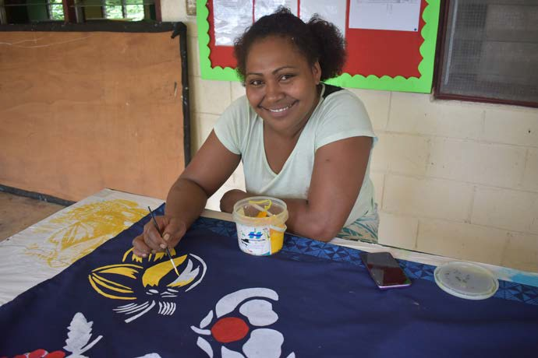
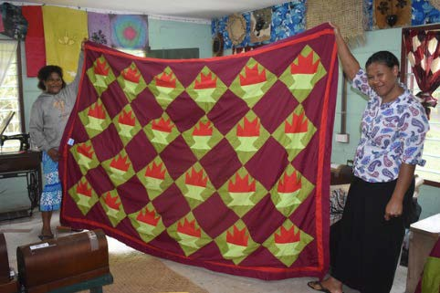

Young men and women at Tutu Rural Training Centre develop their skills for their future.

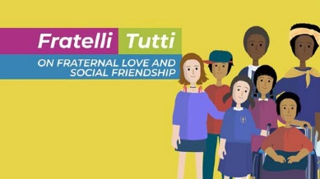
WEEK TWO ACTIVITY IDEAS

Like the students in Fiji, you are all very lucky to have teachers that help you to develop your skills in school.
What is one thing you have learnt to do because of your teacher(s)?
Make a thank you card for your teacher to let them know you value their help and the effort they make.
Y1-4 (JUNIOR PRIMARY)

Watch the animation that summarises Pope Francis’ letter called Fratelli Tutti.
Discuss the main points that you want to remember with others. How do the messages of the letter connect with the photo board about life in Fiji
recently? Remember the people of Fiji and pray for them.
Y5-8 (SENIOR PRIMARY)

Research the Internet to find out which countries in the Pacific were affected most by COVID-19 and how long different countries were in lockdown. What
are some of the lasting impacts of the pandemic on these countries?
Find out more about the cyclones that have made landfall in Fiji in recent years.
Unlike the disciples, who didn’t speak of what they saw, share your findings with your family and friends.
Y9-10 (JUNIOR SECONDARY)

As we reflect on the impact of COVID-19 within Fiji, it is only natural that we think of our experience too.
Take time to consider how your experience of the pandemic (lockdowns and other impacts) connects to some
of the main Catholic social teaching principles. How relevant are the likes of the common good, subsidiarity, solidarity, preferential option for the poor and vulnerable etc?
Y11-13 (SENIOR SECONDARY)



KEEP IT SIMPLE FOR LENT
Check out the simple actions outlined in the Action Plan for this week. Take the challenge to complete some of these.
PRAY
GIVE
LIVE
DO
FIND
Pray for people who may be alone
or isolated.
Every time you feel
gr
ateful for your friends
and spread a messag
Be a peacemaker
e of
or your education put a donation in the koha box.
peace by sharing a poem or prayer with others.
Organise a Caritas Challenge event at your school to support people in the Pacific.
Find a Bible verse that encourages us to love others and share it with your friends.

WEEK THREE

When things are bad, it is easy to lose hope. We can be drawn to the difficulties and feel like there is no way out. It is important to focus on what we have and what can be achieved with God’s help.
Sometimes time and changing circumstances provide a fresh perspective.
Theme: Waiting in Hope

Conflict has caused many problems in the Holy Land for a long time. The majority of the population living in the West Bank and along the Gaza strip are living below the poverty line and are dependent
on international aid. Caritas Jerusalem has two healthcare centres in the West Bank providing healthcare and education to children and families.
In the recent conflict, Caritas Jerusalem again used mobile medical units to bring critical health services to thousands of people where they lived. Youth groups and farmers have also been supported in different ways to help alleviate poverty.
Caritas Focus: Holy Land

“God is always waiting for us. He never grows tired. Jesus shows us this merciful patience of God so that we can regain confidence and hope — always!” – Pope Francis, 2013

God of peace and hope, we pray for those in the Holy Land whose lives have been turned upside down by conflict. We remember especially those who are grieving, the injured and those without food, shelter or medical supplies.
We pray also for those who have the power to bring peace. May they be touched by a spirit of compassion and kindness. Lord hear us. Amen.
(Adapted from a CAFOD prayer)
Prayer

- Is there someone you know who could do with some support at the moment?
- What practical things could you do to provide them with hope?
Questions for Students

Luke 13:1-9
Summary:
- Jesus is told about Galileans who were killed by Pilate.
- Jesus asks whether they think that because the Galileans suffered that they were any worse than others.
- He reminds them about the importance of repentance.
- After mentioning an accident that happened in Jerusalem with a tower killing 18 people, he repeats the message, “unless you repent, you will all perish just as they did.”
- Then he tells the parable of the barren fig tree.
- A man looks for fruit from a fig tree that was planted on his vineyard.
- It has produced no fruit in the last three years so he asks the gardener to cut it down as it is wasting the soil.
- The gardener requests that the man waits one more year before he cuts it down and promises to give it attention and care (putting manure on it).
Read the full Gospel reading by clicking here
Sunday Gospel Reading

The Gospel reading calls us not to focus on who has done wrong or who has done worse wrongs. Rather, it reminds us to repent and follow God.
Caritas Jerusalem’s focus is not on determining who is at fault but rather on providing care to those affected – mainly the poor and marginalised.
At first glance, the parable of the fig tree does not appear to have a profound message. However, in the context of the situation in the Holy Land, where many fig trees grow, it is perhaps more profound. Amidst despair, there is always hope – especially with God’s presence and help. Caritas Jerusalem has adaptively responded over the past 20 years to changing circumstances. With God’s help, and the patience of so many, they have shown that fruit can come from even the most unpromising things.
Reflection

PHOTO BOARD: HOLY LAND

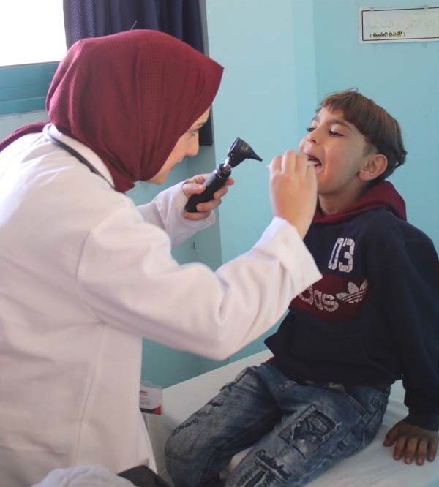
Life has been tough in the Holy Land with ongoing conflict, challenges due to the pandemic, and general health issues.
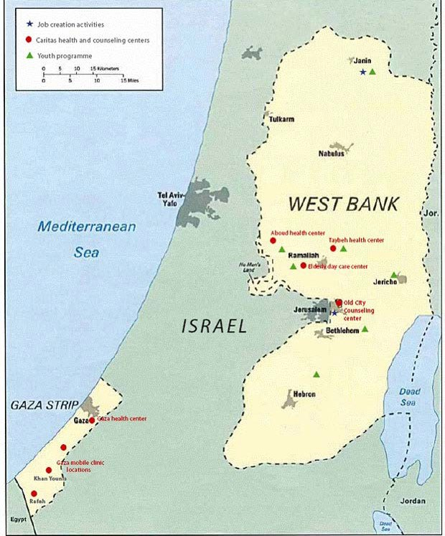
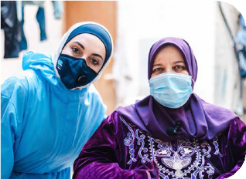

Caritas Jerusalem’s presence.
Watch an amazing example of the Caritas Jerusalem team caring for a family during the pandemic.
Covid response video
Later this year, Catholic schools around New Zealand will take part in Mufti Mania and support a school in the Holy Land.
Find out more here.
Credit: Julianne Hickey / Caritas Aotearoa NZ
Credit: Asmaa El Khaldi / Caritas Internationalis

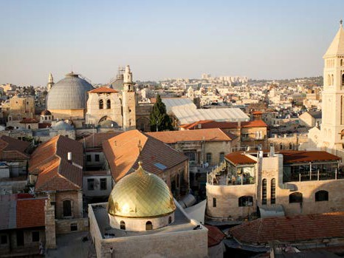
CST Spotlight
Common
Good
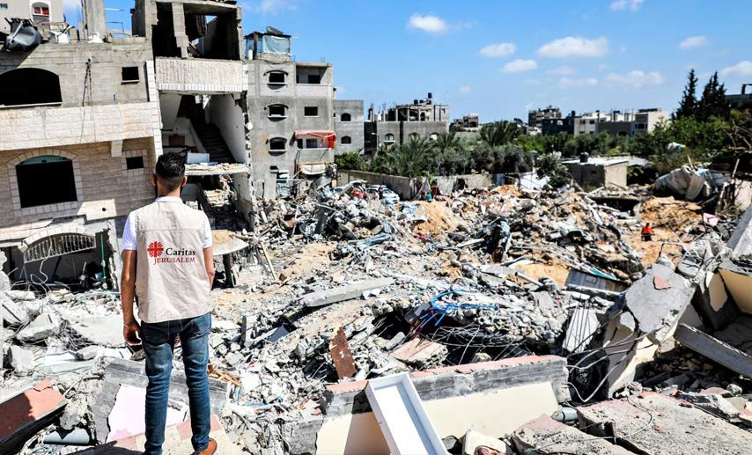
Conflict escalated in May 2021 between Gaza and Israel. Sr. Bridget Tighe, the General Director of Caritas Jerusalem said that “the bombs are falling almost 24-hours-a-day. Sometimes, there
is a 2-hour break in the middle of the night, when people try to sleep and then it starts again.”

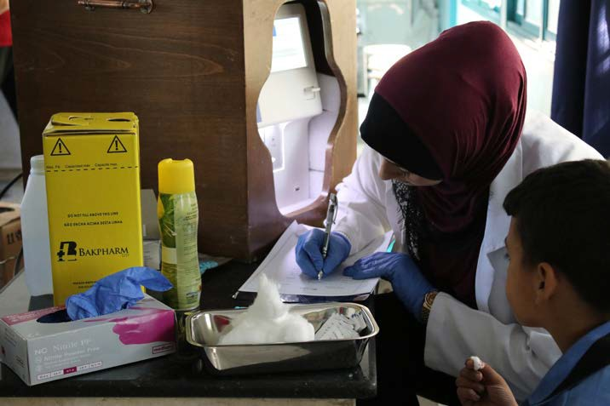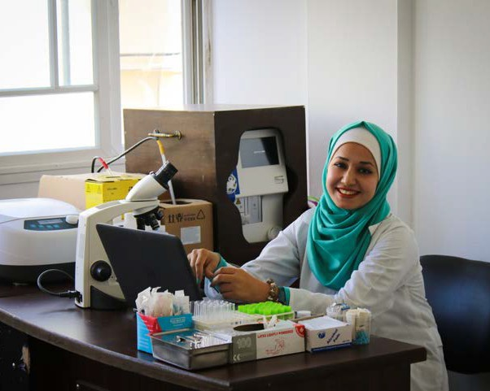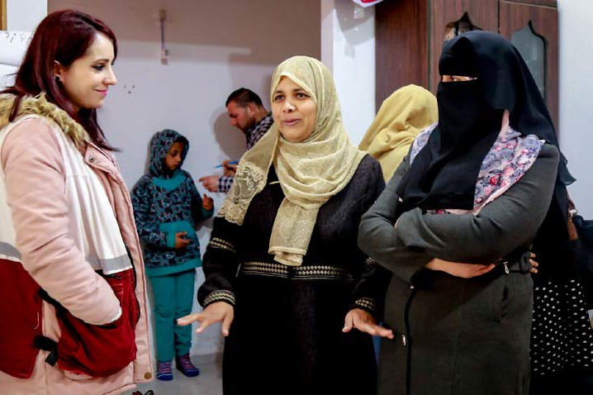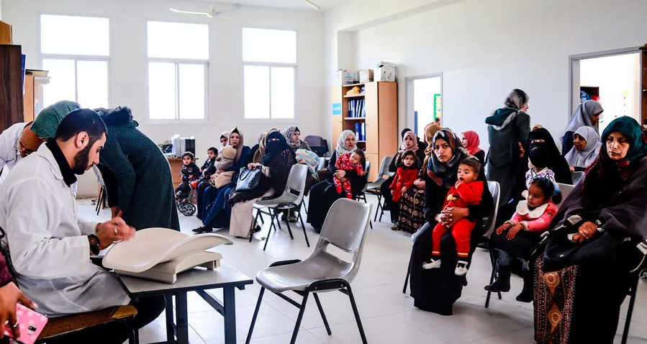

Local doctors and nurses spend their days helping out children in the mobile health clinics.
Local people from a refugee camp wait their turn to get the free medical healthcare provided by Caritas Jerusalem in Gaza.

WEEK THREE ACTIVITY IDEAS
Y1-4 (JUNIOR PRIMARY)
Y5-8 (SENIOR PRIMARY)
Y9-10 (JUNIOR SECONDARY)
Y11-13 (SENIOR SECONDARY)







KEEP IT SIMPLE FOR LENT
Check out the simple actions outlined in the Action Plan for this week. Take the challenge to complete some of these.
PRAY
LIVE
DO
FIND
CREATE
Take time just to sit and listen and spend time with God.
Follow St Teresa of Calcutta’s wise words: ‘A life not lived for others is not a life.’
Every day this week choose your words wisely to bring joy and hope to others.
Find out more about recent events in the Holy Land by searching the Internet.
Make a space in your class or your room at home and display quotes of hope and inspiration.

Choose another one of Jesus’ parables for your teacher to read to the class.
In small groups act out this parable and try to work out the message that Jesus was sharing.
Work with your teacher to find a safe free space in your school grounds where you can plant a small sapling/ tree.
Work out a roster to care for this tree so that it has a great chance to grow or bear fruit in time.
This tree can be a regular reminder for you to seek God, care for others, and to wait in hope.
Write a short message of support to the Caritas Jerusalem team to encourage them to continue their amazing work amidst ongoing struggles.
You may choose to write this as a class or personally as individuals.
Send your message(s) to exeutive.director@caritasfiji.com we can pass it on to Sr Bridget (their General Director).
Watch the short CAFOD video The Holy Land: A Brief History to discover what has been happening in the Holy Land.
Then use your skills on the web to find out more about why the conflict began in the first place and what has been happening in recent years.
Share your findings with those close to you. And remember to pray for those affected throughout the Holy Land.

Click here to watch a short CAFOD video that provides a brief history of the Holy Land.

WEEK FOUR

“All of us have a responsibility for the wounded, those of our own people and all the peoples of the earth.
Let us care for the needs of every man and woman, young and old, with the same fraternal spirit of care and closeness that marked the Good Samaritan.” – Pope Francis, Fratelli Tutti, #79

The global Caritas network consisting of 165 Caritas agencies stretches to every country on our planet. In fact, Caritas is the second largest humanitarian network in the world. Every year, we witness emergencies on a large scale and the Caritas network
responds to all of these to meet the needs of those most affected, working with them to ensure a fresh start.
The photo board on the next page provides examples of where and how Caritas responded to emergencies in 2021. This included the pandemic response in India, landslides and flooding in Indonesia, the earthquake in Haiti, unrest in Afghanistan and ongoing needs in Bangladesh.
Caritas Focus: Emergency Response

- Has there been a local or global emergency lately? How could you help?
- Do you know anyone who is making a fresh start? How could you support them?
Questions for Students

God of hospitality, at times we wander from you, and you call us home. You always rejoice in those who are lost but now are found. Open our hearts to those who are making a fresh start. God of hospitality, inspire us all to act with kindness to welcome families and individuals who are starting again in our local community or even on the other side of the world. May your love abound. Amen.
Prayer

Sometimes we face a situation where we are forced to make a fresh start. This can provide new opportunities but is often difficult as well.
As we continue on our Lenten journey, let’s turn our attention to those who have had to start again.
Theme: A Fresh Start

Luke 15:1-3, 11-32
Summary:
- Tax collectors and sinners were coming to listen to Jesus and the Pharisees were complaining that Jesus was dealing with people like them.
- Jesus told them the Parable of the Prodigal Son.
- A man had two sons.
- The youngest son asked for his share of the inheritance so his father gave this to him. Soon after, the son left for a distant land and spent all of this money. He found himself without anything during a famine and was feeding pigs. He realised he needed to return to his father and say sorry and ask if he would have him back.
- The father ran to meet him and asked his slaves to provide him with clothes and to prepare a feast using the fatted calf as his son was ‘alive again’ and ‘found’.
- The eldest son heard the celebrating and found out that it was for his brother. He was angry and refused to join in. He pointed out to his father that he had never done the same for him even after his endless obedience and service.
- The father explained that his eldest son had always been with him but his brother was lost and now found, dead and now back to life, so they had to celebrate.
Read the full Gospel reading by clicking here
Sunday Gospel Reading

In the Gospel reading, we discover a father who is full of compassion regardless of what the younger son has done. He celebrates the fact that his son is now both found and alive again. His love and care are instrumental in providing his son a fresh start and another go at life.
The father we read about in the Parable of the Prodigal Son has the same qualities as our father in heaven. God is both loving and willing to help us start again.
Millions of people around the world have been forced to start again due to disasters and emergencies they have experienced. Caritas, as love in action, plays a key role in enabling these communities to begin again by walking with them in solidarity at the hardest point in their lives when they have lost everything.
Reflection

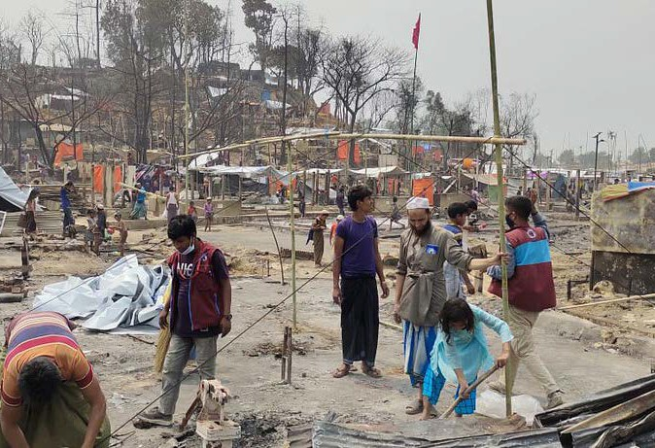
PHOTO BOARD: EMERGENCY RESPONSE

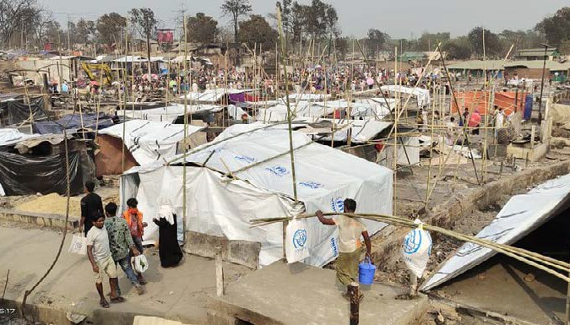
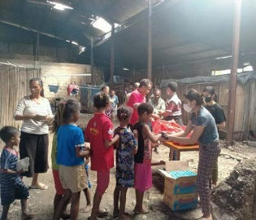

Recent emergencies in 2021

Indonesia
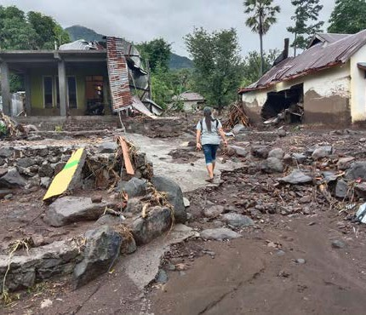
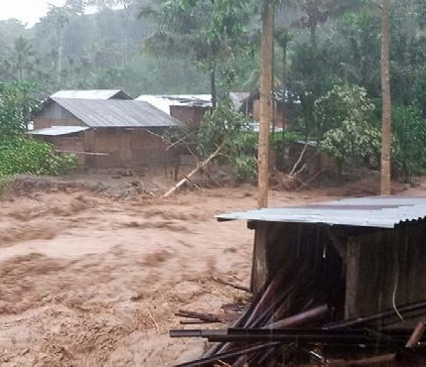
Credit: Caritas Indonesia/ Caritas Atambua

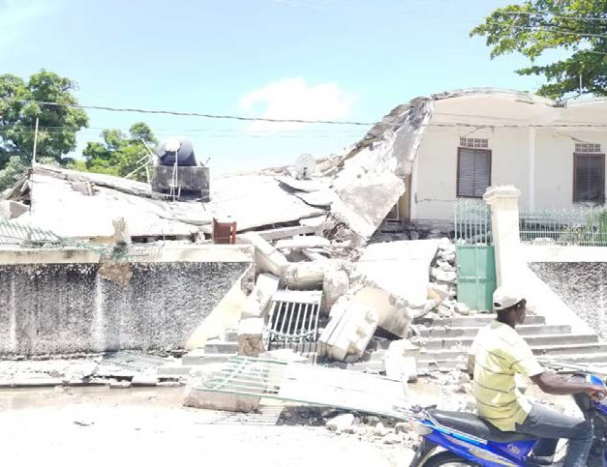
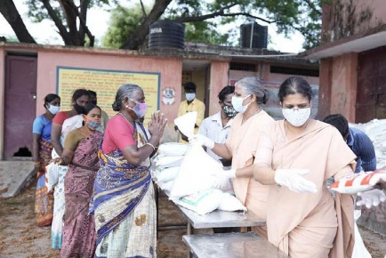
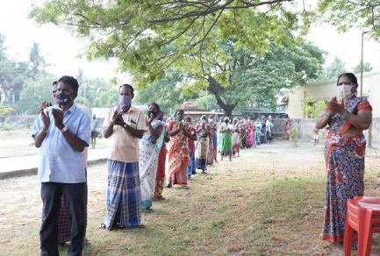


Caritas Indonesia responded to massive flooding and landslides caused by Cyclone Seroja. The disaster damaged or destroyed thousands of homes and forced many people to take refuge in evacuation centres. Catholic youth volunteers helped Caritas distribute items and clear debris and mud from people’s homes. More than 181 people were confirmed dead, 12,344 were displaced, 47 were missing and 258 injured from the flash floods and cyclone which hit the East Nusa Tenggara islands on the 4th of April last year. 66,509 houses were affected during the flash floods and whirlwind.
India
Credit: Caritas Internationalis

Afghanistan

Bangladesh


Caritas Bangladesh responded to a widespread fire in a Rohingya camp. Emergency teams on the ground were able
CST Spotlight
Preferential Option
for the Poor and
Vulnerable
Credit: Caritas Bangladesh/Al Imran
to re-build shelters and provide cash support. The fire left 45,000 homeless and over 120,000 in desperate need of sanitation. This disaster was the latest trauma to affect the Rohinyga population, one million of whom fled persecution in their homeland in Myanmar. Then terrible flooding impacted four hundred villages in Cox’s Bazar later in 2021 and families were again left shelterless as everything was submerged. Food and clean water were needed.
Credit: Caritas India

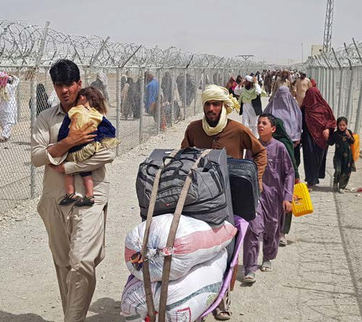
As a result of the Taliban's seizure of power in Afghanistan, thousands of refugees fled to neighbouring countries, including Pakistan, and there was an increasing need for humanitarian assistance. Caritas
Pakistan provided food (dry rations), kitchen sets, bedding sets, shelter and hygiene kits.

Haiti

Haiti experienced a devastating earthquake on 14 August 2021 (7.2 on the Richter scale). Many were affected and basic needs like food, water, tents, hygiene kits and first aid were provided by Caritas Haiti in immediate response.
Credit: CRS
Caritas India appealed for global solidarity to help them respond to a second wave of the COVID-19 pandemic which was ravaging the country. A record 300,000-plus daily infections were being recorded in India in 2021 and oxygen and medical supplies were running low and the healthcare system was challenged. Caritas India has been
supporting communities throughout the pandemic. It mobilised staff and volunteers to operate a COVID information centre and offer food, primary healthcare and medical support, including oximeters and inhalers, in response to the second wave.

WEEK FOUR ACTIVITY IDEAS

As a class, create country flags of the places around the world that have been impacted by disasters/ emergencies recently.
Find the flags first and then draw and colour larger versions on posters.
Display these flags on your classroom wall and use them as a prayer focus as we remember families affected and their fresh starts.
Y1-4 (JUNIOR PRIMARY)

Create a short story or poem that is inspired by either the story of the prodigal son or a Caritas emergency response.
Think about the feelings of those involved.
How do they feel as they are faced with a fresh start?
What happens in their future?
Y5-8 (SENIOR PRIMARY)

Follow current events this week and take note of all local and global events that involve fresh starts.
You may choose to keep them in a scrapbook or save them in a Word document or Google doc.
Use these as the focus of your prayers this week.
Y9-10 (JUNIOR SECONDARY)

Support a recent emergency response by organising a fundraiser at your school.
Find out accurate information to raise the awareness amongst students at your school.
Come up with a fun and relevant activity to collect funds to make a difference for impacted communities.
A Caritas Challenge event could be a possible option.
Y11-13 (SENIOR SECONDARY)




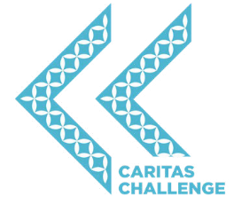
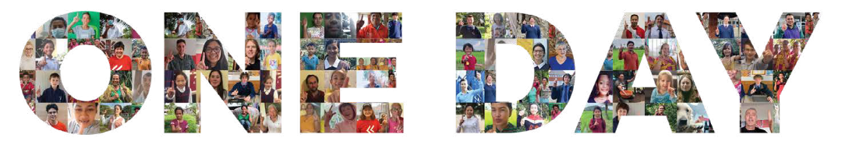
KEEP IT SIMPLE FOR LENT
Check out the simple actions outlined in the Action Plan for this week. Take the challenge to complete some of these.
PRAY
GIVE
LIVE
DO
CREATE
Pray for those around the world, particularly refugees, who are making a fresh start.
Donate an item of food to a local food bank
to help families in your community.
Write down a list of all the things you are thankful for in your life.
Learn how to say thanks in three new languages.
Design a presentation for others at your school to raise awareness for refugees.

WEEK FIVE

Life is a journey with many different pathways. Our choices determine where we go, who we meet, and ultimately where we end up. We all are given great opportunities at different points on our journey. It is important to firstly see these as opportunities and then to take them whenever we can.
Theme: Great Opportunities

In Timor-Leste, 80% of women are not paid for their work. Caritas supports
a women’s group called HAFOTI that enables Timorese women to rise above their circumstances, and have greater confidence and enhanced dignity as family leaders and community participants.
By using a co-operative business model, HAFOTI members run micro-enterprises. Women have great opportunities to develop their individual skills in remote locations, gain access to resources, and earn an income for their families. HAFOTI empowers many of its members to ultimately progress into leadership and mentoring roles.
Caritas Focus: HAFOTI

“Let us together pray… that every family has dignified housing, access to drinking water… that all can enjoy the peace and security which they rightfully deserve on the basis of their infinite human dignity.” – Pope Francis, Kenya, 2015

John 8:1-11
Summary:
- Jesus went to the Mount of Olives.
- As per usual, he went to the temple early in the morning.
- People came and he taught them.
- The scribes and the Pharisees caught a woman in adultery and brought her before the crowd and Jesus.
- They stated that the law of Moses commanded that the woman should be stoned to death.
- They asked Jesus what his response would be to test him so that they might have a charge to bring against him.
- Jesus said nothing but bent down and wrote his finger on the ground.
- They kept questioning him and so Jesus stood up and said “Let anyone among you who is without sin be the first to throw a stone at her.”
- He the continued to write on the ground.
- The crowd left, one by one, until Jesus was alone with the woman.
- Jesus asked the woman, “Has no one condemned you?”
- She affirmed this before Jesus told her, “Neither do I condemn you. Go your way, and from now on do not sin again.”
Read the full Gospel reading by clicking here
Sunday Gospel Reading

God of Love,
Some people are capable of transforming difficult situations into something joyful with a simple smile.
They seem to possess an inner light.
They are channels of your love in the world. Help us to be your instruments in the world, to bring joy through a simple smile and a helping hand.
May we always be generous in sharing the gifts which you have given us.
Amen.
Prayer

- What opportunities do you have to impact the world in a positive way?
- How can we remember to be more like Jesus and be quick to forgive rather than to judge?
Questions for Students

In the Gospel reading the woman caught doing wrong does not have too many supporters and may have been killed if Jesus had not been in the temple. Jesus disarms the crowd and points out that only those who are perfect should do the judging. No-one met this description except Jesus himself. Yet he was quick to forgive and return the woman’s dignity by giving her another opportunity and a reminder to change her ways.
Like Jesus, HAFOTI restores the dignity of women in Timor-Leste providing them with great opportunities. Many of the women have faced tough challenges in their lives and their connection to HAFOTI provides direction and hope for their future.
Reflection


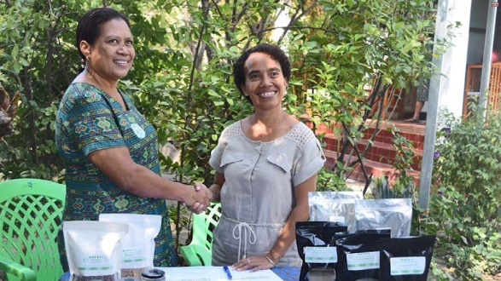
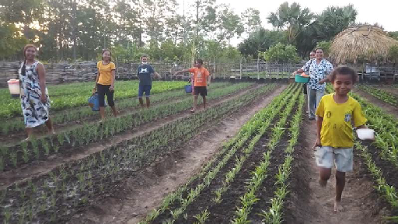
PHOTO BOARD: HAFOTI IN TIMOR-LESTE
CST Spotlight
Subsidiarity

Finding new opportunities for selling products is important.
Watch the HAFOTI members in action
Credit: HAFOTI
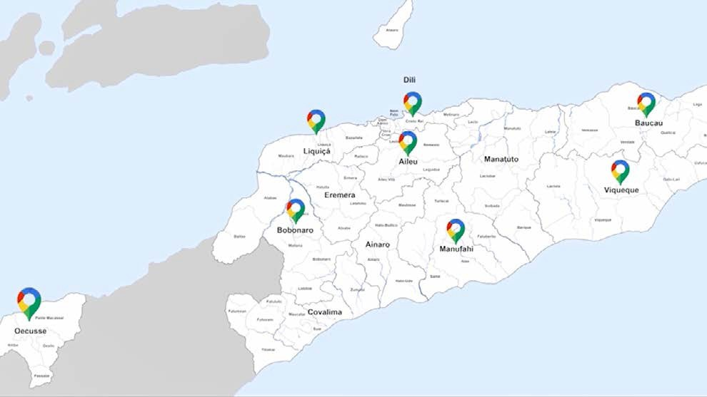
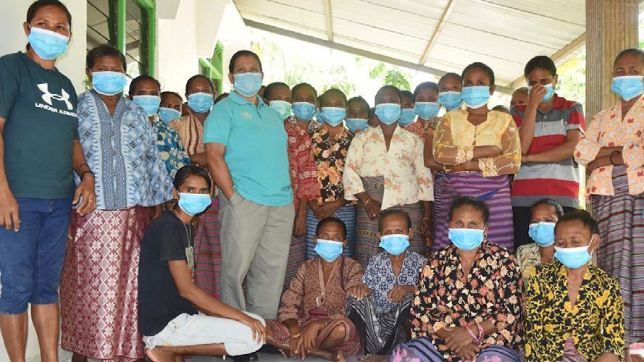
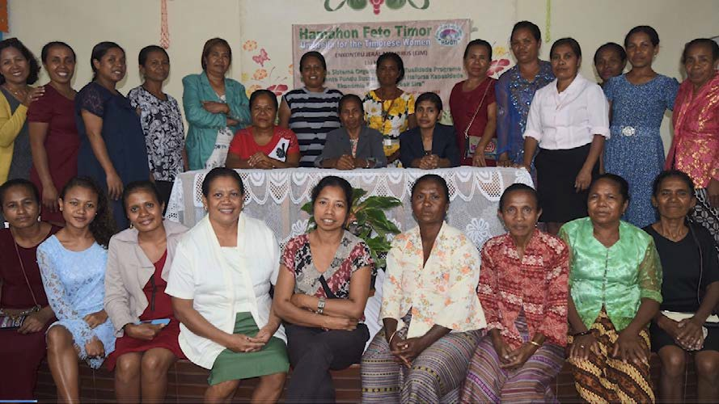


HAFOTI members live all across the country in 8 main regions. The pandemic has provided lots of challenges for HAFOTI.
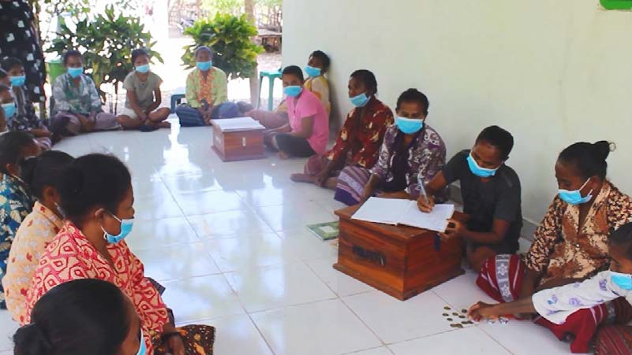
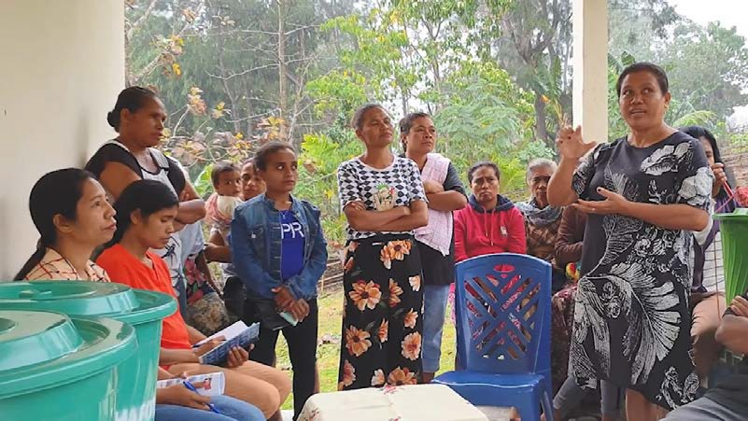
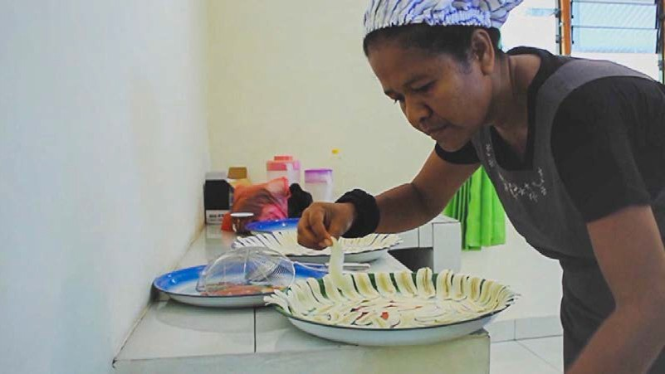
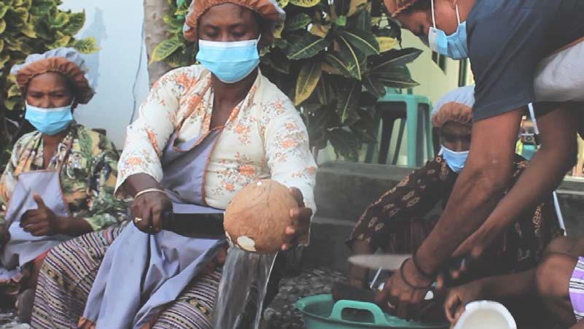
Meetings are important within the local groups for training, direction and finance. It takes a lot of hard work to produce the products.
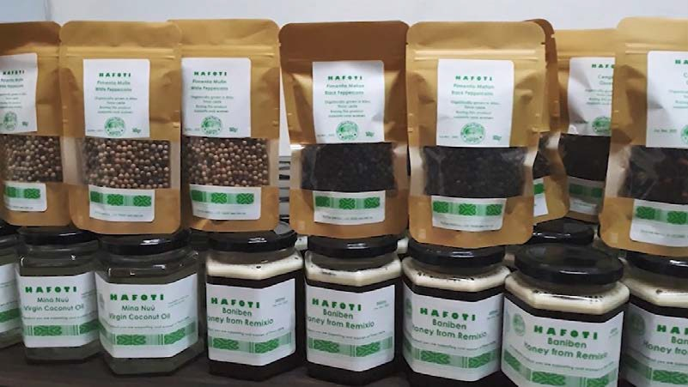
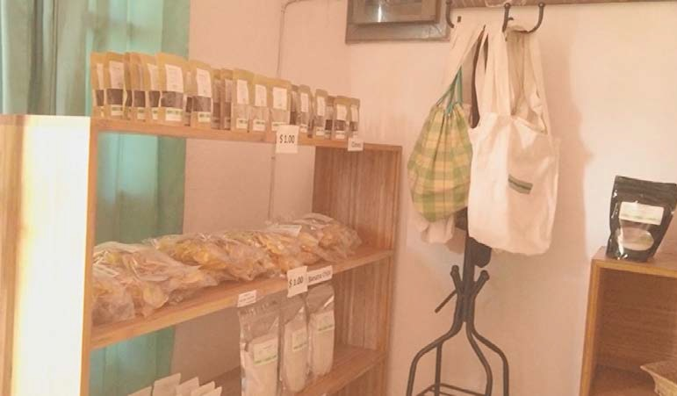
The HAFOTI shop in Dili showcases all the amazing local products which are eventually sold.

WEEK FIVE ACTIVITY IDEAS
Y9-10 (JUNIOR SECONDARY)
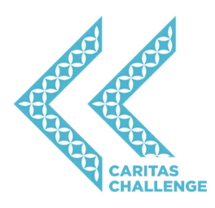
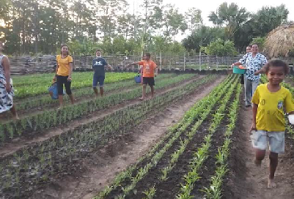

KEEP IT SIMPLE FOR LENT
Check out the simple actions outlined in the Action Plan for this week. Take the challenge to complete some of these.
GIVE
LIVE
DO
FIND
CREATE
Put a coin in the koha box to help Caritas
Take part in the Sacramental programme.
Take the chance to do something nice for one person today as a random act of kindness.
Watch the HAFOTI in Timor-Leste video then see if you can find Timor- Leste on Google Maps.
piece of artwork tha
Create a poem or a
t
support families around the world.
highlights respect and human dignity.
Watch the HAFOTI in Timor-Leste video and discuss how Timorese women have been given great opportunities through HAFOTI.
What was surprising?
Y1-4 (JUNIOR PRIMARY)

The people of Timor have a lovely story that tells the tale of a boy and his friend the crocodile. It is a legend about how the land came to look like it does. It is also a good story about kindness and friendship.
Watch a video of The Boy and the Crocodile being read aloud.
Discuss what we can learn form the story and how it relates to our Lenten goals.

Register today for the Caritas Challenge and as senior leaders organise a fun day for all the students at your school.
You may choose to focus on a sweat it activity for students to understand that many around the world (like the HAFOTI women) have to work very hard to just have enough each day.
Y5-8 (SENIOR PRIMARY)

Many women around the world have the tough task of looking after their families even though they are living well below the poverty line.
Find out more about the current international poverty line and the demographics of those that live below it at sites including: Worldbank & WHO.
Why CST are principles like subsidiarity and participation so important (as seen in the work of HAFOTI)?
Y11-13 (SENIOR SECONDARY)
What can we learn from this back here in New Zealand?

HOLY WEEK

God of mercy, we thank you for the sacrifice of your Son, our
Saviour, Jesus Christ. Help us to be compassionate and merciful as you are compassionate and merciful. Help us to see how
we might show compassion to those most in need. We make our prayer through Christ our Lord. Amen.
Prayer

Holy Week is the culmination of Lent, as we remember the sacrifice of Christ on the cross. The manner of Jesus’ death is unjust and horrific but it is the reality of the resurrection that brings hope, peace and life
anew. Jesus, as the ultimate peacemaker, gave us the greatest gift of all – overcoming sin and death.
Theme: The Greatest Gift of All

Holy Week provides the perfect opportunity for following the Stations of the Cross to remember Jesus’ journey to the cross.
There are many ways this activity can be organised. The Caritas slides are designed to help large groups or small groups follow the stations together one after the other from the same location. These slides can also be printed and left in different locations for students to move between if that is more helpful.
Stations of the Cross

“Jesus on the Cross feels the whole weight of the evil, and with the force of God’s love he conquers it, he defeats it with his resurrection.” – Pope Francis, World Youth Day, 2013.

- How will you remember Jesus’ sacrifice on the cross this week? What does it mean to you?
Questions for Students

Luke 23:32-49
Summary:
- At the place called The Skull, Jesus is crucified along with two criminals.
- Jesus says, “Father, forgive them; for they do not know what they are doing.”
- The soldiers cast lots to divide his clothing while the crowd watch.
- Leaders and soldiers challenge Jesus to save himself if he is indeed the Messiah.
- An inscription was placed over him saying, ‘This is the King of the Jews.’
- One of the criminals yelled at Jesus and said, “Are you not the Messiah? Save yourself and us!”
- The other criminal rebuked him and reminded him that they were getting what they deserved for what they had done, but Jesus had done nothing wrong.
- He then asked Jesus to remember him when Jesus came into his kingdom.
- Jesus replied, “Truly I tell you, today you will be with me in Paradise.”
- Darkness then came over the land from midday to three in the afternoon.
- The curtain of the temple was torn in two and Jesus cried out with his last breath, “Father, into your hands I commend my spirit.”
- The centurion seeing this firsthand knew that Jesus was innocent and praised God.
- The crowds that had gathered returned home beating their breasts.
- Jesus’ friends, including the women from Galilee, stood watching at a distance.
Read the full Gospel reading by clicking here
Sunday Gospel Reading

As Jesus hung on the cross, he didn’t cry out at the injustice of it all. He didn’t cry out at the pain he was feeling. Instead he talked to God and was focused on forgiving those who had caused his suffering.
As Pope Francis points out, Jesus ‘feels the whole weight of evil’ yet he conquers it ‘with the force of God’s love’. He is indeed the greatest gift of all, the one who transforms our relationship with God for all eternity.
There are many observers at Jesus’ crucifixion. It is interesting to reflect on who we most resemble...
Jesus’ friends – sad and shocked watching at a distance; others in the crowd – angered at the injustice they saw;
the centurion – whose life was amazingly changed by Jesus; the guards – who laughed and mocked Jesus;
the criminals – who joined in Jesus’ pain.
Even though we’ve heard the story of Jesus’ crucifixion many times, let’s stop and reflect on the impact for us personally.
Reflection

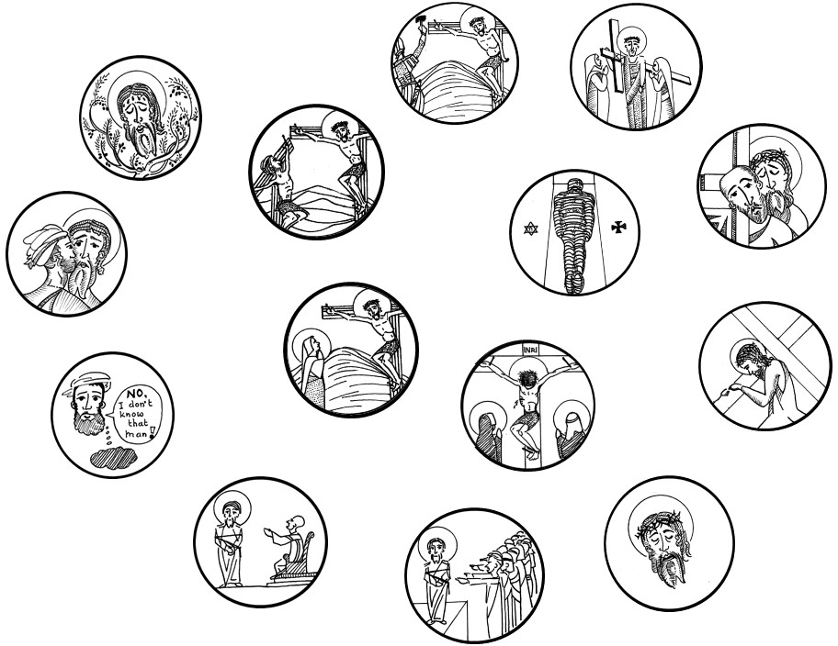

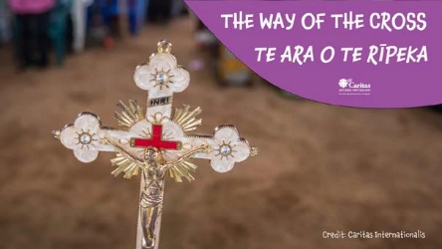
THE WAY OF THE CROSS

11
1

2 12
9

10 14

CST Spotlight

Human Dignity

8

7

13
6
3 4

5
Click here for the PowerPoint

HOLY WEEK ACTIVITY IDEAS

Reflect on the goals that you may have set at the beginning of the Lenten period. Did you manage to achieve these? What could you continue doing beyond Lent? In what ways can you be a peacemaker? How can you help build dreams with others to make a difference in the world?
What are the most important things that you have learnt during Lent? How can you remember these things and learn from them in the future?
ALL LEVELS

In the lead up to the events of Holy Week, take time together using The Way of the Cross to remember what Jesus experienced two thousand years ago to transform the world as the ultimate peacemaker. You will find the relevant Scriptures for each station as well as a relevant reflection connecting to various places around the world based on recent events.
ALL LEVELS

Click here for the PowerPoint



KEEP IT SIMPLE FOR LENT
Check out the simple actions outlined in the Action Plan for this week. Take the challenge to complete some of these.
PRAY
GIVE
DO
FIND
CREATE
Give thanks to God for Jesus’ amazing sacrifice and for the gift of love and grace.
Wash each other’s feet at the end of Lent.
Participate in a special liturgy for Holy Week.
Find out how different countries and cultures celebrate Holy Week.
Write a card to someone special to tell them what they mean to you.

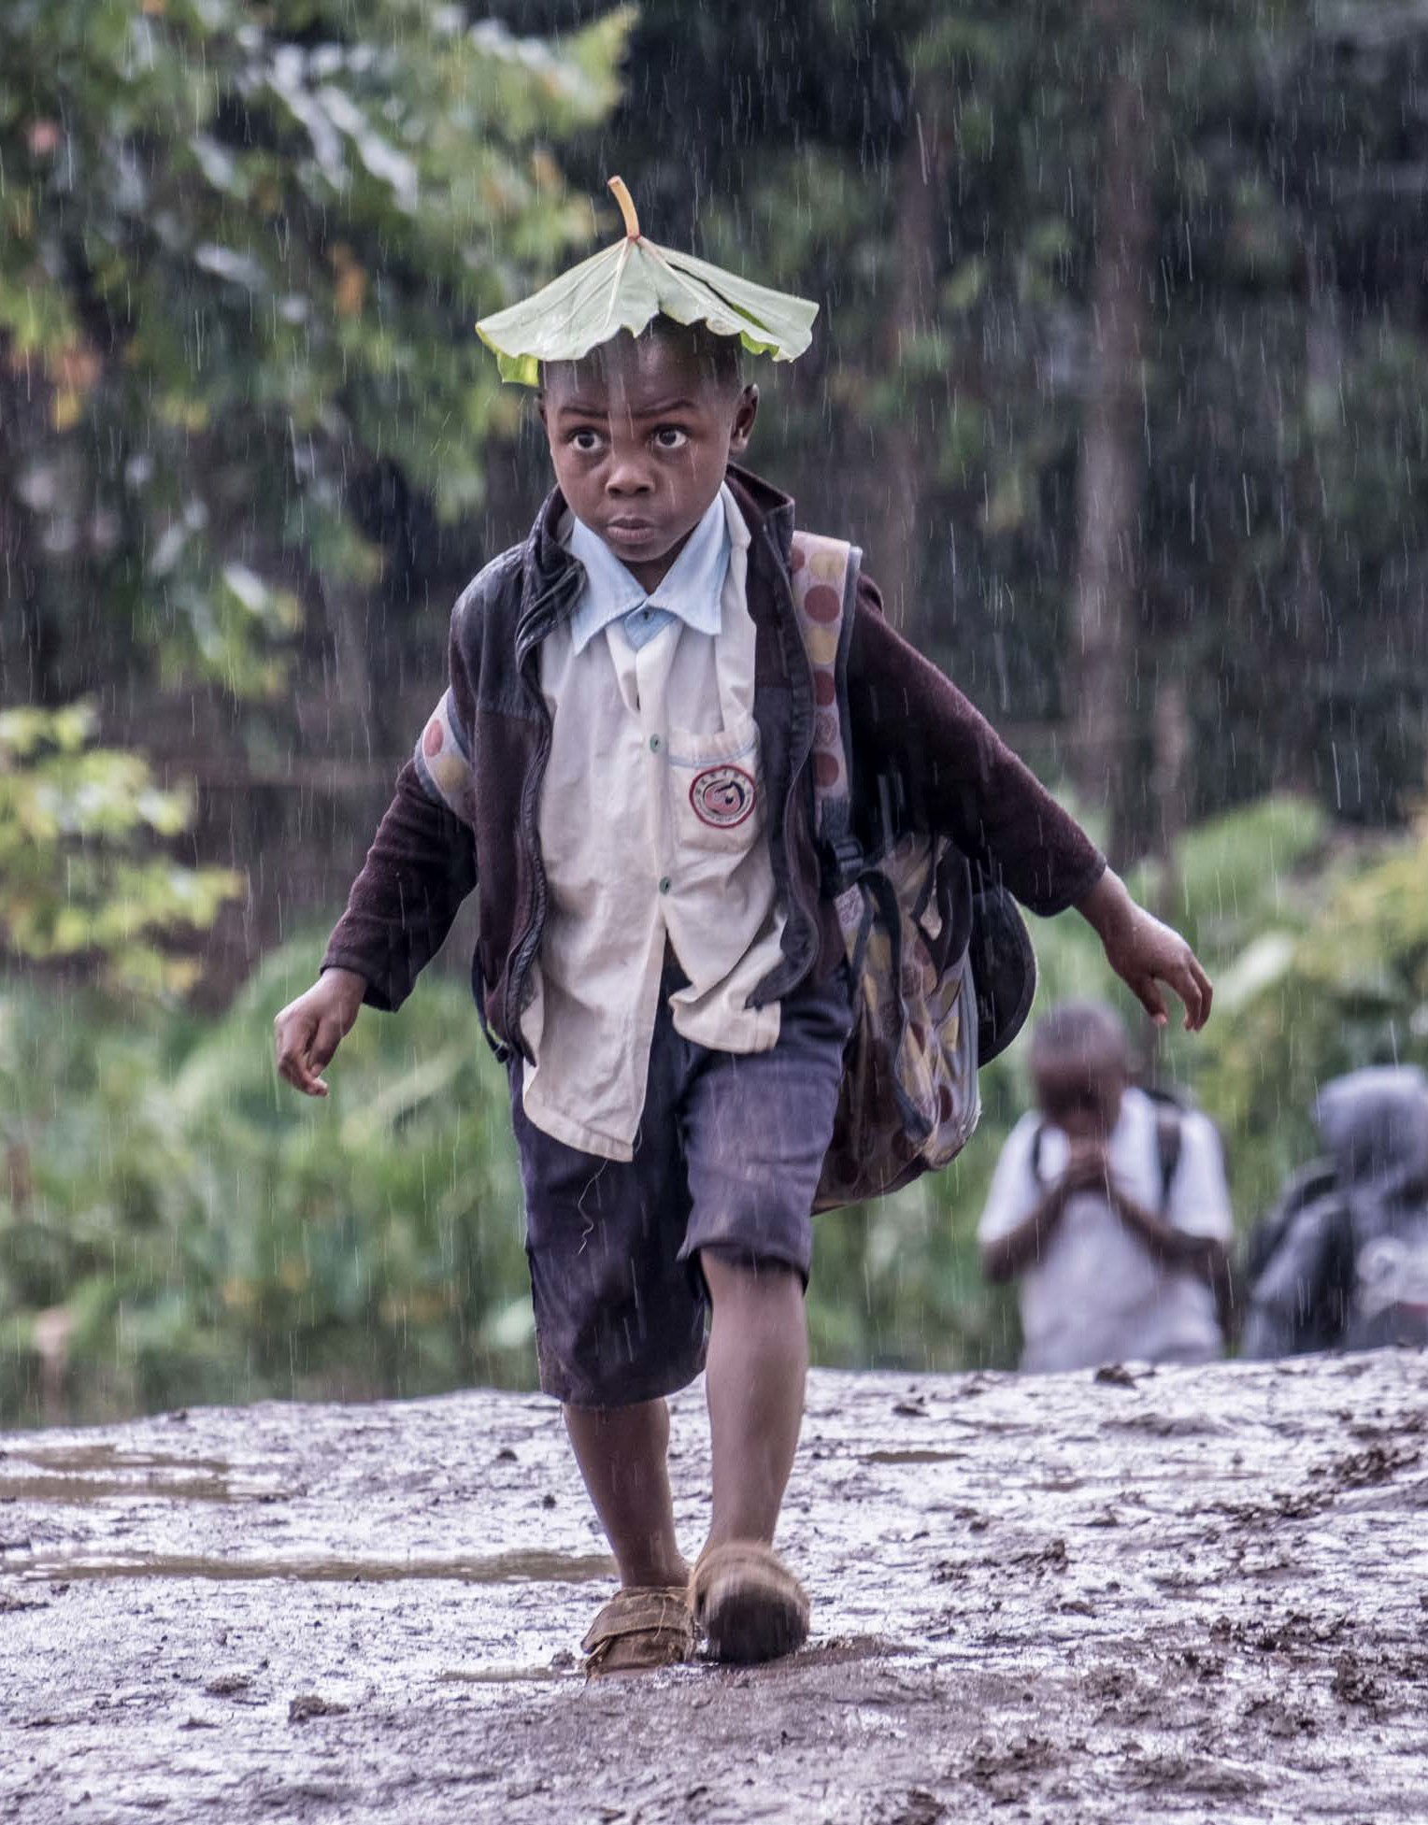
ACKNOWLEDGEMENTS
Credit: Caritas Internationalis

Writing – Michael Stewart
Country project contributions – Phil Brass and Amanda Craddock Design – Rose Miller
Editing – Graeme Siddle
Translations – Piripi Walker and Dcn. Danny Karatea-Goddard The Way of the Cross sketches – Johannes Sijbrant
Video narration – T.J. Tuimavave

Thanks to everyone who provided their feedback and constructive ideas to the creation of this resource (including teachers and staff).




r
ARCHDIOCESE OF SUVA

Special thanks to the members of the Caritas staff /volunteers and country partners around the world who make it possible to build dreams together and bring peace where it is needed most.

